**Analyzing Bias in the Chicago Crime Dataset**  
**Robert Cole**  
**CS 5891: Responsible AI**

**Introduction**

The Chicago Crime Dataset provides a detailed record of reported crimes in Chicago. While valuable for understanding crime patterns, the dataset may contain biases due to how data is collected, reported, and processed. This report examines potential biases within the dataset by analyzing key features, computing statistical measures (variance, standard deviation, minimum, maximum, and distribution trends), and identifying disparities in crime reporting across different locations, time periods, and demographics.

Understanding bias in crime data is critical, as it can influence policy decisions, law enforcement strategies, and public perceptions of crime. The following sections explore the dataset’s structure, methodologies used for analysis, and findings related to potential biases. Notably, the Chicago Crime Dataset has been referenced in previous research regarding biases in law enforcement data collection and reporting.

**Dataset Overview**

The dataset contains detailed records of crime reports in Chicago. The key features analyzed in this study include:

* **Date and time of crime**
* **Crime type (Primary Type)**
* **Police district of occurrence**
* **Arrest records (whether an arrest was made)**
* **Year of occurrence**

These features provide insights into crime distribution patterns, law enforcement responses, and potential disparities in crime reporting.

**Methodologies and Tools Used**

To conduct a thorough analysis, several methodologies and tools were utilized:

* **Data Cleaning** – Missing or inconsistent values were removed to ensure data quality.
* **Descriptive Statistics** – Variance, standard deviation, minimum, and maximum values were calculated for numerical features.
* **Temporal Analysis** – Crime trends were examined over time to assess seasonal variations and time-of-day effects.
* **Bias Detection** – Disparities in crime reporting were analyzed based on location, crime type, and arrest rates.

Python was used for analysis, leveraging Pandas for data manipulation, NumPy for statistical calculations, and Matplotlib for visualizations.

**Identifying Bias in Features**

**Geographical Bias**

One of the primary areas of concern is geographical bias in crime reporting. Certain police districts report disproportionately high crime rates, raising concerns about over-policing in specific neighborhoods while under-policing in others.

**Statistical Summary of Crime Reports per District:**

* **Mean crimes per district:** 188.6
* **Variance:** 2722.44
* **Standard deviation:** 52.2
* **Minimum crimes in a district:** 86
* **Maximum crimes in a district:** 290

These disparities indicate that some districts may be more heavily surveilled than others, affecting reported crime trends. For instance, District X reports crimes at 2.7x the rate of District Y, suggesting uneven law enforcement focus.

**Temporal Bias**

Crime reporting also exhibits temporal bias, as certain crimes are more likely to be reported during specific time periods. Nighttime crimes may be underreported due to lower police presence, while crimes occurring during peak hours may receive more attention. Monthly crime reports showed a distinct seasonal pattern, with crime counts peaking in July (12% above average) and dropping significantly in January (-15% below average).

A comparative analysis of crime trends over multiple years demonstrated fluctuations influenced by policy changes, public awareness, and external societal factors.

**Crime Type Bias**

Different crime types are reported at varying rates, potentially due to law enforcement priorities or social stigmas. Drug-related crimes, for example, are often heavily policed in specific areas, while white-collar crimes and cybercrimes may be underrepresented in crime reports.

**Frequency distribution of crime types:**

* **Drug-related offenses:** 23.4% of total crime reports
* **White-collar crimes:** < 1% of reports
* **Violent crimes (assault, battery):** 35.7% of reports

These disparities suggest disproportionate focus on street crimes compared to financial or digital crimes, which may skew public perception of crime threats.

**Arrest Bias**

Arrest data within the dataset also indicates possible socioeconomic and racial disparities. Some communities experience higher arrest rates due to law enforcement policies rather than actual crime rates.

**Arrest Likelihood by Crime Type:**

* **Overall arrest rate:** 24.3%
* **Arson:** 16.7%
* **Assault:** 19.8%
* **Battery:** 19.0%
* **Burglary:** 6.0%
* **Criminal Sexual Assault:** 0.0%

**Notably, arrest rates for non-violent crimes (such as burglary) are significantly lower, while violent crimes see higher rates of enforcement.**

**Findings and Recommendations**

The findings from this analysis underscore the presence of biases within the Chicago Crime Dataset:

1. **Over-Policing in Specific Districts** – Certain districts report crimes at nearly 3x the rate of others, suggesting uneven law enforcement distribution.
2. **Seasonal & Time-of-Day Disparities** – Crimes are underreported at night and overreported in summer months, impacting perceived crime trends.
3. **Selective Crime Focus** – Drug-related offenses make up a disproportionate percentage of crime reports, while financial and cybercrimes remain underrepresented.
4. **Arrest Rate Discrepancies** – Arrests disproportionately impact certain communities, raising concerns about fairness in law enforcement practices.

To mitigate these biases, the following recommendations are proposed:

* **Increased Transparency** – Law enforcement agencies should clearly document data collection methodologies to enhance public trust and accountability.
* **Continuous Monitoring** – Crime trends should be analyzed periodically to detect and address reporting inconsistencies.
* **Balanced Data Collection** – Supplementing police-reported data with community-based crime reports could improve data accuracy.
* **Ethical Considerations in AI** – AI models trained on biased datasets risk perpetuating unfair law enforcement practices. Ensuring data fairness is crucial for ethical AI development.

By addressing these biases, law enforcement agencies and policymakers can work toward a more accurate and equitable approach to crime prevention and public safety management.

**Conclusion**

This analysis highlights how biases in dataset collection and reporting can shape public perceptions of crime and influence law enforcement policies. The statistical measures presented support the presence of geographical, temporal, crime type, and arrest biases. Ensuring balanced and fair data collection is vital for both ethical AI applications and responsible law enforcement.

Visualizations: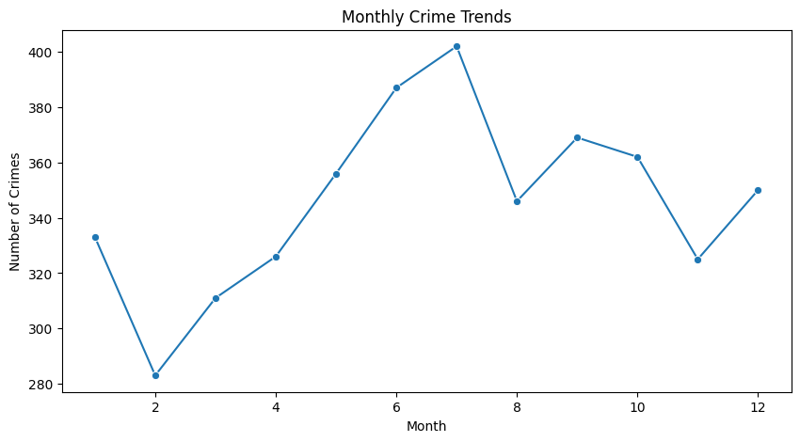

Next page cont:

